

CAPSTONE PROJECT REPORT
Report 1 – Project Introduction

Automatic Attendance System Based on Real-Time Location and Face Recognition

INSTRUCTOR: BÙI THỊ LOAN
CLASS: SEP490_G16

Team Members:
- Trần Long Khánh | HE176617
- Nguyễn Đình Dũng | HE176518
- Hà Việt Hiếu | HE176256
- Nguyễn Văn Đạt | HE176009
- Kiều Thị Ngọc Dung | HE171203

Hanoi, June 2025

Abstract
The Project Introduction document for our Capstone—Automatic Attendance System Based on Real-Time Location and Face Recognition—provides a comprehensive roadmap that aligns academic requirements, user needs, and technical execution. It opens by framing the motivation: traditional attendance methods are time-consuming, error-prone, and vulnerable to proxy check-ins. Against this backdrop, our mission is to harness students’ smartphones as both location beacons (via Bluetooth Low Energy propagation) and identity verifiers (via on-device face recognition), delivering a seamless, scalable solution without extra hardware.
Building on a review of existing techniques (RFID, NFC, fixed BLE beacons, one-time face scans) and their limitations in cost, coverage, continuous tracking, and security, the document defines four functional domains—Authentication, Application (Student, Lecturer), Admin Website, and System automation—each illustrated by detailed use-case tables. It then describes the end-to-end architecture: mobile apps (student/lecturer roles) that broadcast and scan BLE advertisements in timed “rounds,” invoke face-matching for liveness checks, cache data offline, and synchronize with a central REST API and web portal for session setup, analytics, threshold alerts, and complaint handling.
Core sections cover system requirements, use-case analysis, component diagrams, the Bluetooth propagation-based method, UI wireframes, and an experimental plan. By uniting real-time location graphs with biometric verification and an offline-first strategy, the Project Introduction document lays the conceptual and technical foundation for building, evaluating, and defending a robust, user-friendly attendance platform that meets both academic and operational goals.

Table of Contents
Abstract 1
Definitions & Acronyms 4
I. Record of Changes 5
II. Project Introduction 6
1. Overview 6
1.1 Project Information 6
1.2 Project Team 6
2. Product Background 6
2.1 Global Attendance Context 6
2.2 Vietnamese Attendance Context 6
2.3 Stakeholder Requirements 6
2.4 Rationale for This Project 7
3. Existing Systems 7
3.1 Jibble 7
3.2 Additio App 8
3.3 NCheck Bio Attendance 9
3.4 TeacherKit 10
4. Business Opportunity 10
4.1 Global Market Opportunity 10
4.2 Vietnamese Market Opportunity 11
4.3 Comparative Evaluation of Existing Products 11
4.4 Unmet Needs & Strategic Fit 12
5. Software Product Vision 12
6. Project Scope & Limitations 13
6.1 Major Features 13
6.2 Limitations & Exclusions 15

List of Figures
Figure No. | Title | Page
Figure 1 | Existing System: Jibble | 8
Figure 2 | Existing System: Additio App | 9
Figure 3 | Existing System: NCheck Bio Attendance | 10
Figure 4 | Existing System: TeacherKit | 11
Figure 5 | Major Features - Website | 14
Figure 6 | Major Features - Application | 14
Table 1 - List of Figures
List of Tables
Table No. | Title | Page
Table 1 | List of Figures | 4
Table 2 | List of Tables | 4
Table 3 | Definitions & Acronyms | 5
Table 4 | Record of Changes | 6
Table 5 | Project Team | 7
Table 6 | Advantages & Disadvantages of Jibble | 9
Table 7 | Advantages & Disadvantages of Additio App | 9
Table 8 | Advantages & Disadvantages of NCheck Bio Attendance | 10
Table 9 | Advantages & Disadvantages of TeacherKit | 11
Table 10 | Comparative Evaluation of Existing Products | 12
Table 11 | Major Features | 15
Table 12 | Limitations & Exclusions | 18
Table 2 - List of Tables

Definitions & Acronyms
No | Acronyms & Abbreviations | Definition
1 | AAS | Automatic Attendance System
2 | BLE | Bluetooth Low Energy
3 | RFID | Radio-Frequency Identification
4 | NFC | Near-Field Communication
5 | API | Application Programming Interface
6 | REST | Representational State Transfer
7 | UI | User Interface
8 | CSV | Comma-Separated Values
9 | KPI | Key Performance Indicator
10 | MVP | Minimum Viable Product
Table 3 - Definitions & Acronyms

I. Record of Changes
Date | A*  M, D | In charge | Change Description
30/06/2025 | A | DungND | Create report, Add Overview, Product Background, Existing Systems
31/06/2025 | A | DungND | Add Business Opportunity, Software Product Vision
09/08/2025 | M | DungND | Format, Major Feature
19/09/2025 | M | DungND | Format
*A - Added M - Modified D - Deleted
Table 4 - Record of Changes

II. Project Introduction

1. Overview

1.1 Project Information
- Project name: AAS - Automatic Attendance System Based on Real-Time Location and Face Recognition
- Project code: AAS
- Group name: SEP490_G16
- Software type: Android Mobile Application & Web Application

1.2 Project Team

Full Name | Role | Email | Mobile
Bùi Thị Loan | Lecturer | loanbt7@fpt.edu.vn
Trần Long Khánh | Leader | khanhtlhe176617@fpt.edu.vn | 0984851996
Nguyễn Đình Dũng | Member | dungndhe176518@fpt.edu.vn | 0376312235
Hà Việt Hiếu | Member | hieuhvhe176256@fpt.edu.vn | 0346119246
Nguyễn Văn Đạt | Member | datnvhe176009@fpt.edu.vn | 0982775121
Kiều Thị Ngọc Dung | Member | dungktnhe171203@fpt.edu.vn | 0382350016

Table 5 - Project Team

2. Product Background

2.1 Global Attendance Context
Traditional in-class roll calls remain widely used despite their inefficiency. A study of 54 lecture classes (average size ≈ 100 students) found that calling out student numbers takes 4 minutes 20 seconds on average—time that could otherwise be used for instruction (Research Article Lecture-Class Attendance Taking: Roll Number...). Biometric kiosks (e.g., face-recognition at entry) automate the check-in moment but perform only a single scan, are sensitive to lighting and occlusions, and cannot track presence continuously throughout the session(How Does Facial Recognition Work, Benefits & Use Cases).

2.2 Vietnamese Attendance Context
In Vietnam, many universities still rely on paper sign-in sheets or RFID/NFC swipes, leading to congestion at classroom doors and roll-call times of 10–20 minutes per lecture. According to Astute Analytica, the broader Vietnam time-and-attendance software market (across all sectors) is valued at US $9.51 million in 2024 and projected to reach US $20.44 million by 2033 (CAGR 9.11%)—a sign of rising digital adoption but with limited penetration in higher education (Vietnam Time and Attendance Software Market to Hit Valuation of US$ 20.44 Million By 2033).

2.3 Stakeholder Requirements
Key “problem owners” who requested a new solution are:
- Lecturers & Department Chairs, seeking to reduce roll-call delays and obtain real-time attendance dashboards.
- Academic Affairs Offices are charged with compiling and verifying thousands of records each term.
- Students desire a seamless, contact-free check-in experience without queuing or device swapping.

They require a system that:
- Significantly reduce the time required for attendance in each session.
- Prevents proxy attendance through robust identity verification.
- Delivers live analytics and exportable reports for immediate intervention and planning.

2.4 Rationale for This Project
The project is a prototype of an indoor attendance system, designed to be scalable and applicable to various organizations, companies, and educational institutions. To ensure feasibility and manageable testing within the capstone timeframe, the team chose to implement and validate the solution in the context of a university classroom setting — involving students, lecturers, courses, and corresponding schedules.

To satisfy these needs without costly new hardware, our solution turns each student’s smartphone into both a BLE beacon node (forming a resilient mesh that overcomes dead zones) and an on-device face-recognition verifier. Global BLE-beacon infrastructure is booming—valued at approximately USD 1.2 billion in 2024 and forecast to reach USD 3.5 billion by 2033 (CAGR ~12.8%)—underscoring the feasibility of software-centric proximity services. By combining mesh-based propagation algorithms with liveness-checked face matching and an offline-first design, we deliver continuous, accurate, and scalable attendance tracking at minimal incremental cost. (Bluetooth Low Energy (BLE) Beacons Market Insights)

3. Existing Systems

3.1 Jibble
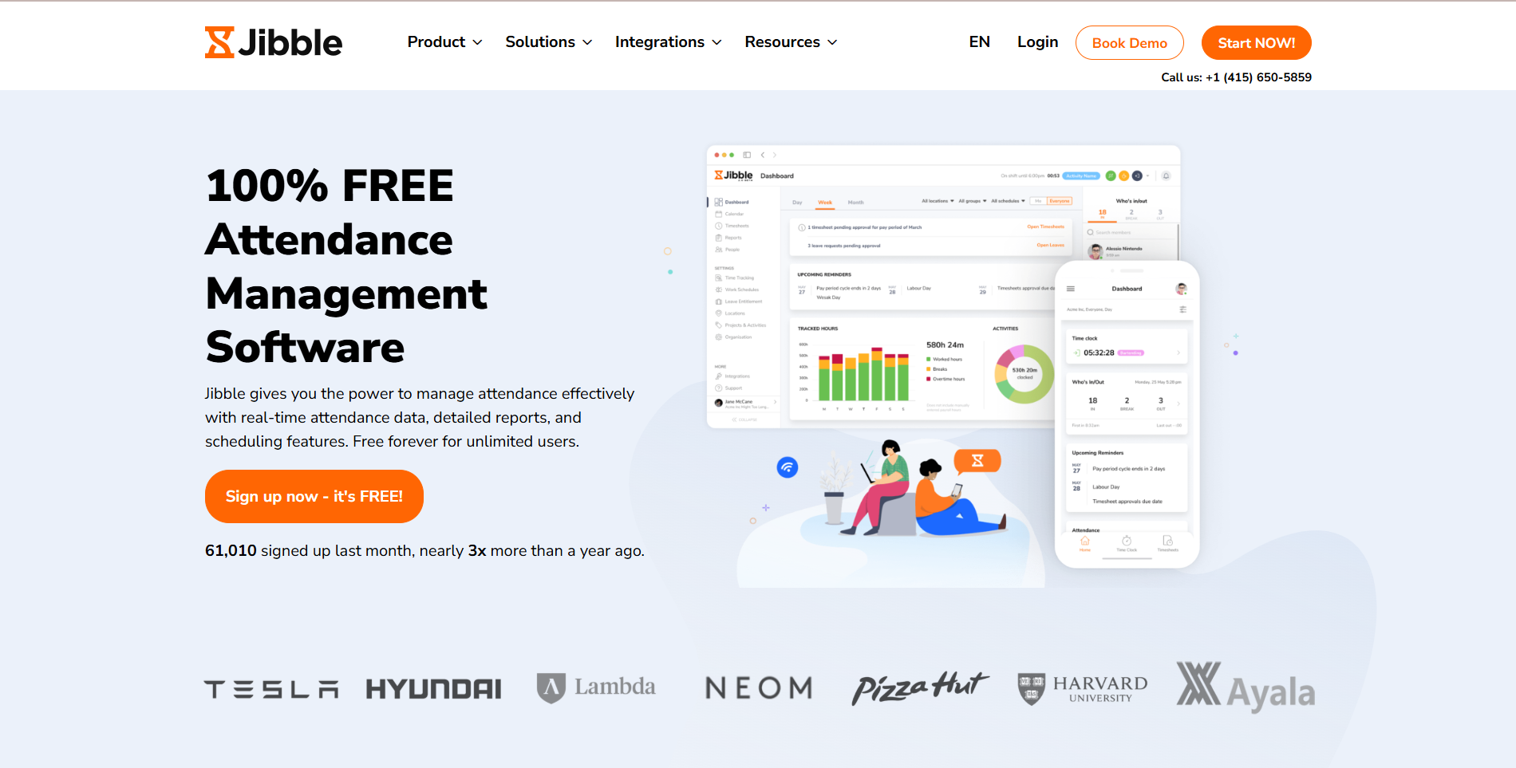
Figure 1 - Existing System: Jibble

- Description: Jibble is a cloud-based attendance and time-tracking platform offering mobile and web apps. It provides real-time clock-in/out, facial recognition or PIN entry, GPS/geofence validation, and detailed analytics on absences, late clock-ins, and early clock-outs. Administrators can access timestamps, location data, and generate customizable reports via the Jibble web portal or mobile app.
- Link: https://www.jibble.io/attendance-management
Advantages | Disadvantages
- Real-time attendance data across devices | - Limited offline capability for remote or no-signal areas
- Built-in facial recognition and GPS/geofence for extra security | - Advanced features (e.g., facial recognition) require a paid plan
- Customizable analytics and exportable reports | - It may be over-featured for small classrooms
- Free tier available for basic usage | - Some users report occasional geolocation inaccuracies

Table 6 - Advantages & Disadvantages of Jibble

3.2 Additio App
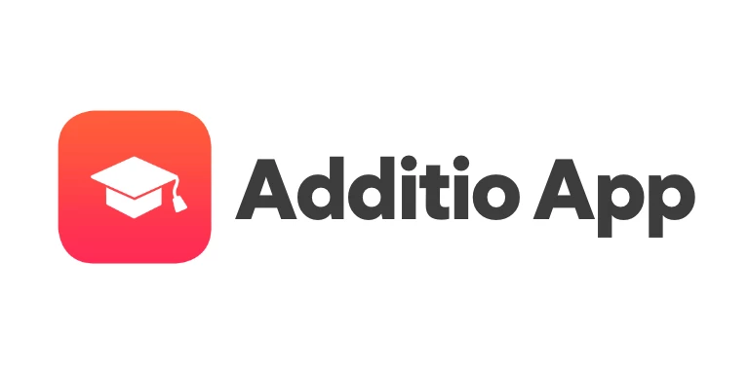
Figure 2 - Existing System: Additio App
- Description: Additio App is a mobile-first classroom management tool for teachers. It allows recording, controlling, and monitoring student attendance directly from smartphones or tablets, online or offline. It also supports incident logging, absence justification, real-time percentage calculations, notifications to families, and custom attendance types.
- Link: https://additioapp.com/en/attendance/ or CH Play
Advantages | Disadvantages
- Full offline support; automatic sync when online | - Core biometric or proximity detection features are not included
- Custom attendance categories, incident tracking, and family notifications | - Advanced features (e.g., integrations) require a paid plan
- Real-time percentage and count; shareable reports | - Primarily designed for K–12; higher-ed customization limited
- Intuitive mobile UI with companion web portal | - No native BLE-based proximity detection

Table 7 - Advantages & Disadvantages of Additio App

3.3 NCheck Bio Attendance
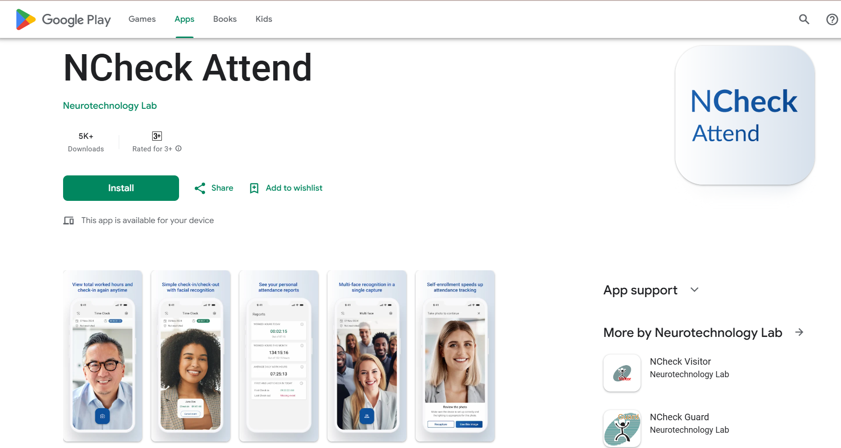
Figure 3 - Existing System: NCheck Bio Attendance
- Description: NCheck Bio Attendance by Neurotechnology is a ready-to-use biometric time-and-attendance system supporting three modalities: face, fingerprint, and iris recognition. Available in on-premises and cloud editions, it can operate offline and provides high-accuracy identification with configurable liveness checks.
- Link: https://www.ncheck.net/ncheck-bio-attendance-product/
Advantages | Disadvantages
- Multi-modal biometrics (face, fingerprint, iris) | - Significant upfront cost for biometric hardware
- Offline operation with automatic sync options | - Installation and maintenance complexity
- High-accuracy liveness detection to prevent spoofing | - Primarily built for enterprise/time-and-attendance use
- Comprehensive audit trail and reporting | - Less mobile-app focus; relies on dedicated scanners

Table 8 - Advantages & Disadvantages of NCheck Bio Attendance

3.4 TeacherKit
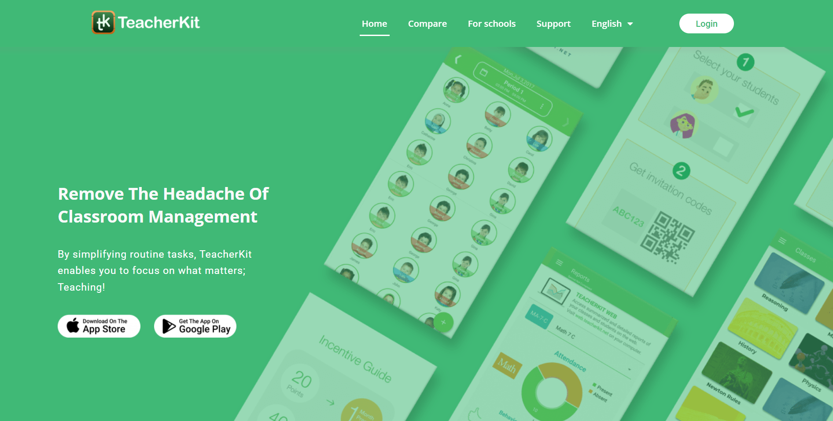
Figure 4 - Existing System: TeacherKit
- Description: TeacherKit is a mobile-first classroom management app for iOS and Android. Teachers can take attendance, manage seating plans, track student behavior, and generate progress reports directly from their devices. Data syncs to a central cloud dashboard for administration and parent communication.
- Link: https://www.teacherkit.net/
Advantages | Disadvantages
- Intuitive mobile interface for rapid attendance taking | - Premium features (e.g., parent notifications) require a subscription
- Supports seating plans, gradebook, and behavior tracking | - The attendance export is limited to Excel/CSV formats
- Works offline and syncs automatically when online | - Designed primarily for K–12; higher-ed features are limited
- Multi-language support and cross-platform availability | - No built-in BLE proximity or biometric verification
Table 9 - Advantages & Disadvantages of TeacherKit

4. Business Opportunity

4.1 Global Market Opportunity
The global time and attendance software market was valued at USD 2.7 billion in 2022 and is projected to reach USD 8.3 billion by 2032 (Time and Attendance Software Market Size,...), growing at a 12.1 % CAGR from 2023 to 2032. A similar forecast pegs the market at USD 3.92 billion in 2023, climbing to USD 11.09 billion by 2033 at a 10.96 % CAGR (Global Time and Attendance Software Market Size,...).

Key drivers:
- Hybrid & remote learning: Institutions need contact-free methods that work both onsite and online.
- Operational efficiency: Organizations seek to reduce administrative burden and eliminate manual errors.
- Regulatory compliance: Real-time, auditable records are increasingly mandated for accreditation and reporting.

Despite this growth, most solutions rely on fixed hardware (e.g., BLE beacons, kiosks) or one-time check-ins (face scans, RFID swipes), leaving room for more flexible, continuous, and cost-effective approaches.

4.2 Vietnamese Market Opportunity
Vietnam’s EdTech market reached USD 1.0 billion in 2024 and is expected to grow to USD 3.0 billion by 2033, at a 12.96 % CAGR from 2025 to 2033 (Vietnam Edtech Market Report). Within this expanding sector:

- Digital campus initiatives (National Digital Transformation Programme) are encouraging “smart campus” deployments.
- High smartphone penetration (over 70 % among university students) provides a ready user base for mobile-first solutions.
- Rising demand for real-time analytics and automated workflows in higher education drives interest in turnkey attendance systems.

However, only a limited number of Vietnamese universities have experimented with automated attendance tools, as high hardware costs and integration complexity remain significant barriers. This gap highlights the substantial opportunity for smartphone-only platforms.

4.3 Comparative Evaluation of Existing Products
Solution Type | Why It Falls Short
- Fixed BLE Beacons | It requires per-room hardware and installation/maintenance costs; it is still spoofable via multiple devices.
- Face-Recognition Kiosks | Single-point scan at entry; cannot track continuous presence; sensitive to lighting/angle.
- RFID/NFC Card Swipe | Manual tap disrupts flow; proxy attendance via card sharing; no biometric verification.
- QR-Code or GPS Check-In | Manual scan or coarse geofencing; easily spoofed by screenshots or GPS spoofing.
Table 10 - Comparative Evaluation of Existing Products
None of these combine continuous mesh-based proximity detection with on-device liveness-checked face matching, leaving a gap for a truly seamless, secure, and infrastructure-light solution.

4.4 Unmet Needs & Strategic Fit
Problems unsolved without our product:
- Continuous coverage: Ensure presence tracking for the entire session, not just at start.
- Proxy prevention: Block “buddy punching” through dual verification (location + biometrics).
- Minimal hardware: Avoid per-room installations and maintenance costs.
- Offline resilience: Log attendance even in low- or no-connectivity scenarios, syncing later.

Alignment with trends and strategy:
- Smart Campus momentum: Our solution dovetails with global “smart campus” initiatives in higher education.
- EdTech growth: As Vietnam’s EdTech market expands, institutions will prioritize software-centric tools over capital-intensive hardware.
- Scalability & cost-effectiveness: A smartphone-only approach scales across multiple campuses with negligible incremental cost.

By addressing these unmet needs, our Automatic Attendance System positions itself to capture a growing slice of both the global time & attendance software market and Vietnam’s fast-digitizing educational landscape.

5. Software Product Vision
Vision Statement
Our vision is to empower educational institutions and corporate training centers with a truly seamless, secure, and scalable attendance solution that transforms every participant’s smartphone into an intelligent presence beacon and identity verifier. By combining mesh-based Bluetooth Low Energy propagation with on-device facial-recognition liveness checks, we eliminate manual roll-call, proxy check-ins, and hardware dependencies—freeing instructors to focus on teaching and administrators to make data-driven decisions in real time.
Imagine a world where the moment a session begins, each student’s phone silently and continuously confirms their presence, even in areas with poor connectivity or without fixed infrastructure. Instructors receive instant alerts if attendance falls below thresholds, students can review their attendance history at any time, and administrators gain rich analytics on participation trends—all without installing a single additional beacon or kiosk.
By enabling offline-first operation, automatic syncs, and role-based dashboards, our system not only modernizes attendance tracking but also aligns perfectly with “smart campus” and digital transformation initiatives. Institutions will reduce labor costs, improve compliance, and enhance the overall learning experience, while students enjoy a frictionless, privacy-respecting check-in process.
Key Objectives
- Continuous, High-Fidelity Tracking: Maintain session-long presence awareness through mesh-BLE propagation and liveness-checked facial recognition.
- Zero-Hardware Overhead: Leverage existing smartphones instead of deploying and maintaining dedicated devices.
- Robust Offline Support: Log attendance locally during network outages, with secure automatic synchronization when connectivity is restored.
- Immediate, Actionable Insights: Provide administrators and instructors with real-time visualizations, alerts, and customizable reports.
- Scalable Deployment: Roll out effortlessly across multiple rooms, buildings, or campuses with negligible incremental cost.
- Privacy-First Design: Ensure biometric data never leaves the device, complying with institutional and regulatory requirements.
Anchored in the realities of current campus architectures and budget constraints, this vision sets the stage for a future where attendance tracking is invisible, reliable, and universally accessible, redefining how organizations manage presence in learning and training environments.

6. Project Scope & Limitations

6.1 Major Features
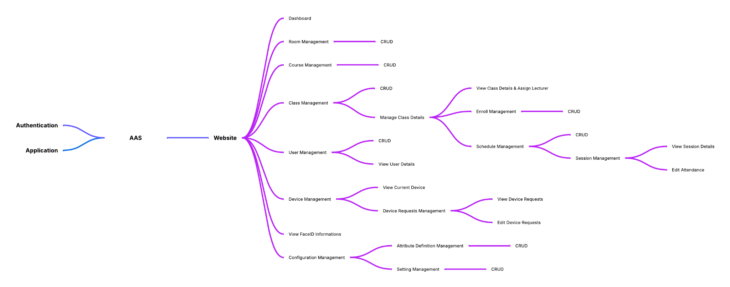
Figure 5 - Major Features - Website
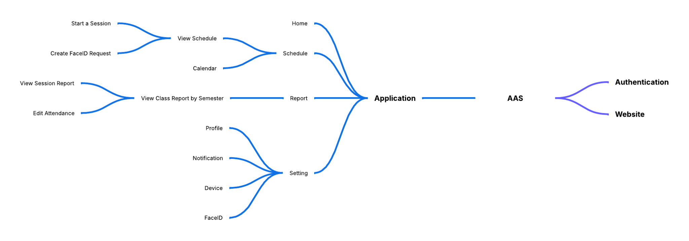
Figure 6 - Major Features - Application

Feature ID | Feature and Description
Application (Student & Lecturer)
FE-01 | Session Notification: Automatically notify students when an attendance session starts.
FE-02 | Process Attendance Data: Validate, store, and manage submitted attendance records securely.
FE-03 | Offline Local Attendance Storage: Temporarily store attendance data locally on device when offline; sync automatically once reconnected.
FE-04 | View Schedule & Calendar: Students and lecturers view class schedules, academic calendar, and upcoming sessions.
FE-05 | Session Control: Lecturers start/end sessions (manual/automatic); students join sessions through the app.
FE-06 | Face-ID Requests: Create, view, and manage requests for Face-ID registration and updates.
FE-07 | Reports (Session & Class): Students/lecturers view session reports; lecturers generate class-level reports.
FE-08 | Attendance Editing: Lecturers edit or override attendance records post-session.
FE-09 | Profile Management: Students/lecturers view.
FE-10 | Notifications: Enable/disable push notifications for attendance warnings, reminders, and system updates.
FE-11 | Device Management (App): Register/view/update BLE-capable devices linked to user accounts.
FE-12 | Face-ID Management (App): Enroll/update on-device Face-ID models used for attendance verification.
Administrator (Web)
FE-13 | Dashboard Overview: Visualize high-level attendance statistics.
FE-14 | Room Management (CRUD): Create, update, delete, and view rooms used for scheduling.
FE-15 | Course Management (CRUD): Manage academic courses (code, name, description, semester).
FE-16 | Class Management: Manage class details (course, lecturer assignment, section code, schedule).
FE-17 | User Management (CRUD): Manage user accounts; view user details and roles.
FE-18 | Device Management (Admin): View current devices, handle device requests (approve/reject).
FE-19 | Face-ID Management (Admin): View student Face-ID information.
FE-20 | Schedule Management (CRUD): Create/update timetables and link classes to sessions.
FE-21 | Session Management: View session details, edit attendance, and handle exceptions.
FE-22 | Attribute Definition Management: Define and manage system-level attributes for attendance processing.
FE-23 | System Settings Management: Configure absence thresholds, warning levels, and rules.
System
FE-24 | System Operations: Securely validate, store, and process attendance data; handle offline data backfill.
FE-25 | System Notifications: Send real-time alerts (session start, threshold breach, complaint response) to relevant users.
Table 11 - Major Features

6.2 Limitations & Exclusions
The following items are explicitly out of scope for the initial release. They may be reconsidered for later versions, subject to budget, schedule, and resource adjustments.
Limitation ID | Limitation and Description
LI-01 | Mobile Platform Support: The mobile application supports Android 7.0+ only; iOS support is deferred to a future release.
LI-02 | Multi-Language & Localization: The user interface is provided in English only; Vietnamese and other language support will be added in subsequent releases.
LI-03 | Face recognition will support basic liveness checks in the initial release but will not cover all advanced attack scenarios. Limitations include: inability to fully prevent 3D attacks or new spoofing techniques, inability to distinguish between identical twins, and lack of support for mask-wearing users. Enhanced security measures will be introduced in future releases.
LI-04 | Strict Timeline: The mobile app will be restricted to the Android platform on the first release.
Table 12 - Limitations & Exclusions

